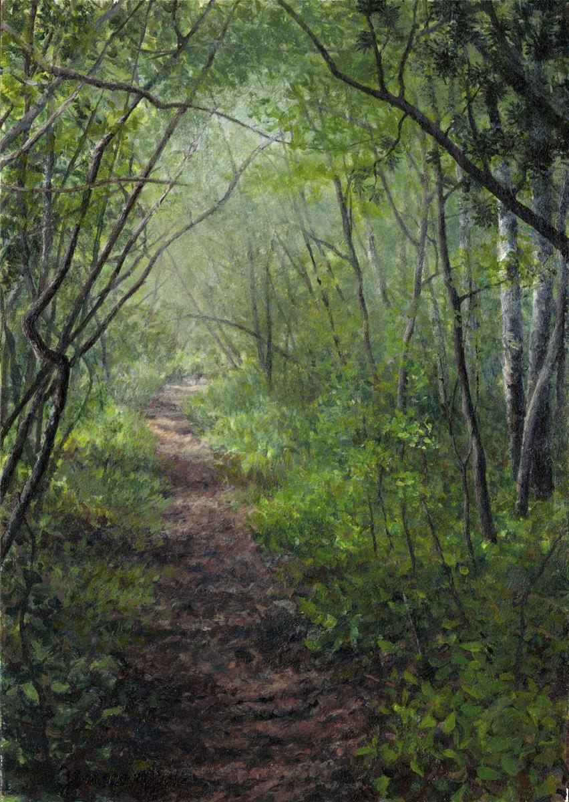

**The translucent wall between you and me**

**The limitless paths among the trees**

**Untouchable, but yet broken with touch**

**Like boundless arms, keeping us safe**

**An angel’s world designed by God**

**The three dimensional void dividing the sky and sea**

**Like weightless, unmeasurable glass**

**Space**

**By Blythe Coss**